PARTICIPANT REGISTRATION FORM – Please return by September 18th 12:00PM (CT)
* Please complete each question with an asterisk and other sections applicable to you.
*Will you be attending in-person or online/ virtually? Please check one: | ☐ I will be attending the event in-person.  ☐ I will attend online/ virtually.
*First Name: | *Last Name:
*First Nation:

Position title:

Organization:

*Phone: | *Email:
*Mailing Address:  Please include:  City, Province &  Postal Code | *Please check one:  ☐ Youth (under 18) *parent/guardian consent required.  ☐ Adult (+18 – 59)  ☐ Elder (+60)
Parent or Guardian Name: | Parent or Guardian Signature:
*Please list an emergency contact and phone number they can be reached at.
*Do you have any food allergies or dietary needs we can accommodate?
Please list any allergen(s) or dietary restrictions (e.g., gluten-free, vegetarian, vegan, etc.)
*Will you be attending the optional field trip to the SVDN Bison Pasture (from 4:00-5:00 PM)? | *Please check one:  ☐ Yes  ☐ No
By signing this participant form, you grant permission for your images, or the images of the minor participant captured during the event with video, photo, audio recording, or otherwise to be reproduced by CM Indigenous Development Ltd. (“CMID”), Sioux Valley Dakota Nation (“SVDN”) Nature Conservancy Canada (“NCC”), and Environment and Climate Change Canada (“ECCC”). You also acknowledge and accept the risks to which you may be exposed during this event, and have read carefully through the Safety Acknowledgement on page 3.
Name of Participant (please print):
Signature (parent/ guardian must sign for a minor):
Date signed:
Please complete each question to the best of your ability. Your responses will help make the discussions and resources more relevant/ helpful to you.
- *What do you value most about nature?
- *What are your community’s biggest priorities? Please respond however you feel is true to your community – there are no wrong answers!

- *What factors, motivations, or perceptions in your community are barriers to protecting nature and achieving your communities’ priorities? (e.g. economic drivers, government policies, societal beliefs, knowledge gaps)

- *What is already being done (current initiatives) to protect nature in your communities? Are they effective? What other concerns would you like to see addressed?

SAFETY ACKNOWLEDGEMENT
While attending the event and optional field trip to the Sioux Valley Dakota Nation Bison Pasture/ Tatanka Ska viewing area, you will be exposed to certain risks or hazards that you should be aware of, which can be mitigated, but not fully eliminated. We do not want to concern you or reduce your enthusiasm to participate in this event, but we believe it is important for you to be informed of any potential risks. Please read this document carefully before signing page 1 of the Participant Registration Form. By signing the Participant Registration Form, you acknowledge and accept the risks to which you (or a minor participant) may be exposed during this event.

Prioritize Safety: Ensure you always act in a way that protects yourself and others from personal injury. At all times you are responsible for your actions, including any negligence and responsible for any potential liability to others, should something you do injure them or cause property damage.

Weather conditions: We will be outdoors for a portion of the event (4:00 – 5:00 PM). Be sure to check the weather forecast, dress for the conditions, and wear comfortable shoes.

Bison Pasture: Please do not attempt to feed, touch, or pet the bison/ buffalo! Bison are large animals and may be unpredictable at times. Please enjoy the bison from the viewing area and do not enter the pasture/ bison compound. Please note, the Bison Herdsmen is under no obligation to allow participants entry into the pasture.

If any participants are observed engaging in any behaviors or actions which could be deemed unsafe, reckless, or disrespectful to the bison, other individual(s), and/or SVDN property, SVDN reserves the right to remove the individual(s) from the event/ activity.

TRAVEL ALLOWANCES AND ELDER HONORARIUMS: Mileage will be provided for participants located within the Southwest Manitoba Priority Place boundary (see next page). Up to 5 vehicles per community at the rate of $0.54/ km (Appendix B - Kilometric Rates - Modules 1, 2 and 3 (njc-cnm.gc.ca). Elder honorariums of $200 are also available, limited spaces. You must register by September 18th, 12:00 PM (CT) to receive payment on the day of the event. After the deadline, you can still register (if spots are available!) and receive reimbursement through a cheque that will be mailed to you. For more details, please contact:
Cheyenne Ironman,
Project Manager
CM Indigenous Development
(204)-761-3053
Cheyenne.ironman@cminiconsulting.ca

PARTICIPANT REGISTRATION FORM – SOUTHWEST MANITOBA PRIORITY PLACE MAP
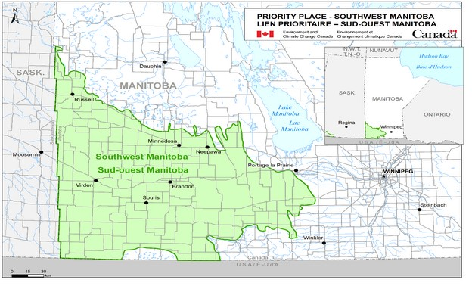
NCC: Where We Work - Manitoba - Southwest Manitoba Priority Place (natureconservancy.ca)
If your First Nation is located within the SWMPP boundary and was missed, we sincerely apologize for our oversight and encourage you to get in touch!
- Birdtail Sioux First Nation
- Canupawakpa Dakota Nation
- Dakota Plains Wahpeton First Nation
- Gambler
- Keeseekoowenin First Nation
- Long Plain First Nation
- Rolling River First Nation
- Sioux Valley Dakota Nation
- Swan Lake First Nation
- Waywayseecappo First Nation; and,
- City of Brandon (must be First Nations from one of the communities listed above).

